Interest of business: Luxury watch (Supplier)

Entities: Transactions, Products, Employees, Seller, Transaction_status

Relational Model in 3NF

* Products: ProductID, Brand, Model, ##etc depends on the business need
* Employees: EmployeeID, LastName, FirstName, ##etc depends on the business need
* Clients: ClientID, LastName, FirstName ##etc depends on the business need
* Transactions: TransactionID, ProductID(fk), EmployeeID(fk), ClientID(fk), Buy/Sell, Cash_recieve/payment_status, Price, Quantity, Transaction_date

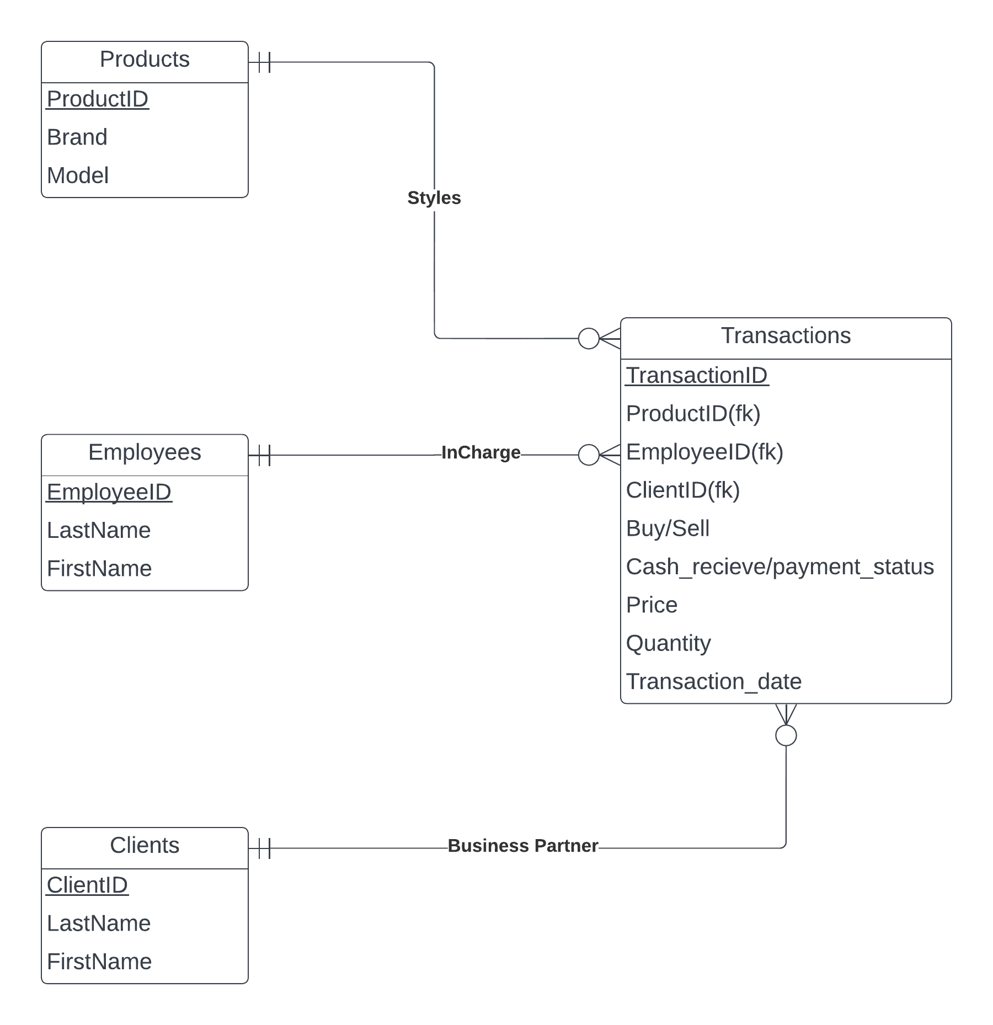**Entity Relationship Diagram**